Monumental O.P.C.V.L.
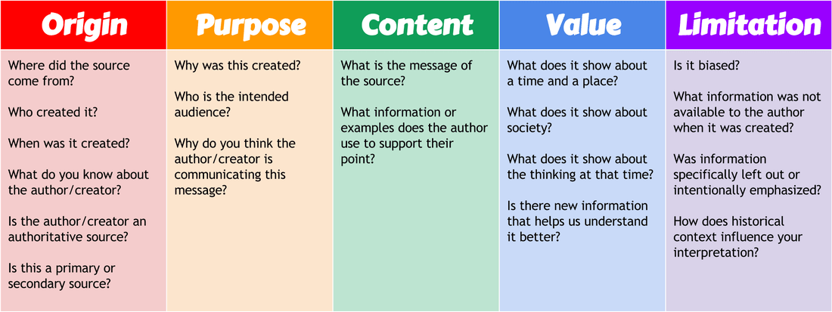
This skills check will function as your year-end final exam. You will be asked to show that you can research a topic, explain your general findings, then think critically about the impact of such a monument that exists in society.
Step 1:
You will start by selecting one of the monuments below.
Step 2:
Spend some time examining the photo provided very carefully.
[How is the statue portrayed? From looking at the statue, what can you speculate about the individual -courageous, an intellectual, great strength, etc.]
Step 3:
Read the newspaper articles below. This will give context for the potential controversies of the monuments.
https://www.theartnewspaper.com/news/canada-addresses-its-monumental-problem
https://www.cbc.ca/news/canada/manitoba/winnipeg-colonial-statues-monuments-reconciliation-1.4997531
https://www.cbc.ca/news/politics/canada-monuments-buildings-legacy-1.4248680
Step 4:
Do some research about the person that your monument represents. Examine TWO legitimate sources (not Wikipedia). Notes should be on a Word document that you hand in. Type out a Reference Page for the sources examined.

Step 5:
Based on your research and the evidence you have gathered about this individual, write a report that answers the following TWO questions:
- Is this a good or appropriate monument?
- Should it stand as it is now, or should it be removed to become more representative of our current value system as a society?

Your report should be 200-250 words.

Self- Assessment
 | Developing  1-2 | Competent  3-4 | Accomplished  5-6 | Exemplary  7-8
Criterion C: Communicating | The student communicates information and ideas in a style that is not always clear, organizes information and ideas in a limited way, lists sources of information inconsistently. | The student communicates information and ideas in a way that is somewhat clear, somewhat organizes information and ideas, creates an adequate reference list and sometimes cites sources. | The student communicates information and ideas in a style that is mostly appropriate to the audience and purpose, mostly structures information and ideas according to the task instructions, creates an adequate reference list and usually cites sources. | The student communicates information and ideas in a style that is completely appropriate to the audience and purpose, structures information and ideas completely according to the task instructions, creates a complete reference list and always cites sources.
Criterion D: Thinking Critically | The student begins to analyse concepts, issues, models, visual representation and/or theories in a limited way, begins to identify connections between information to make simple arguments, recognizes the origin and purpose of few sources/data as well as few values and limitations of sources/data, identifies different perspectives. | The student completes a simple analysis of concepts, issues, models, visual representation and/or theories, summarizes information to make some adequate arguments, analyses sources/data in terms of origin and purpose, recognizing some values and limitations, recognizes different perspectives and suggests some of their implications. | The student completes a substantial analysis of concepts, issues, models, visual representation and/or theories, summarizes information in order to make usually valid arguments, analyses sources/data in terms of origin and purpose, usually recognizing values and limitations, clearly recognizes different perspectives and describes most of their implications. | The student completes a detailed analysis of concepts, issues, models, visual representation and/or theories, summarizes information to make consistent, well-supported arguments, effectively analyses a range of sources/data in terms of origin and purpose, consistently recognizing values and limitations, clearly recognizes different perspectives and consistently explains their implications.

John A Macdonald statue in Montreal
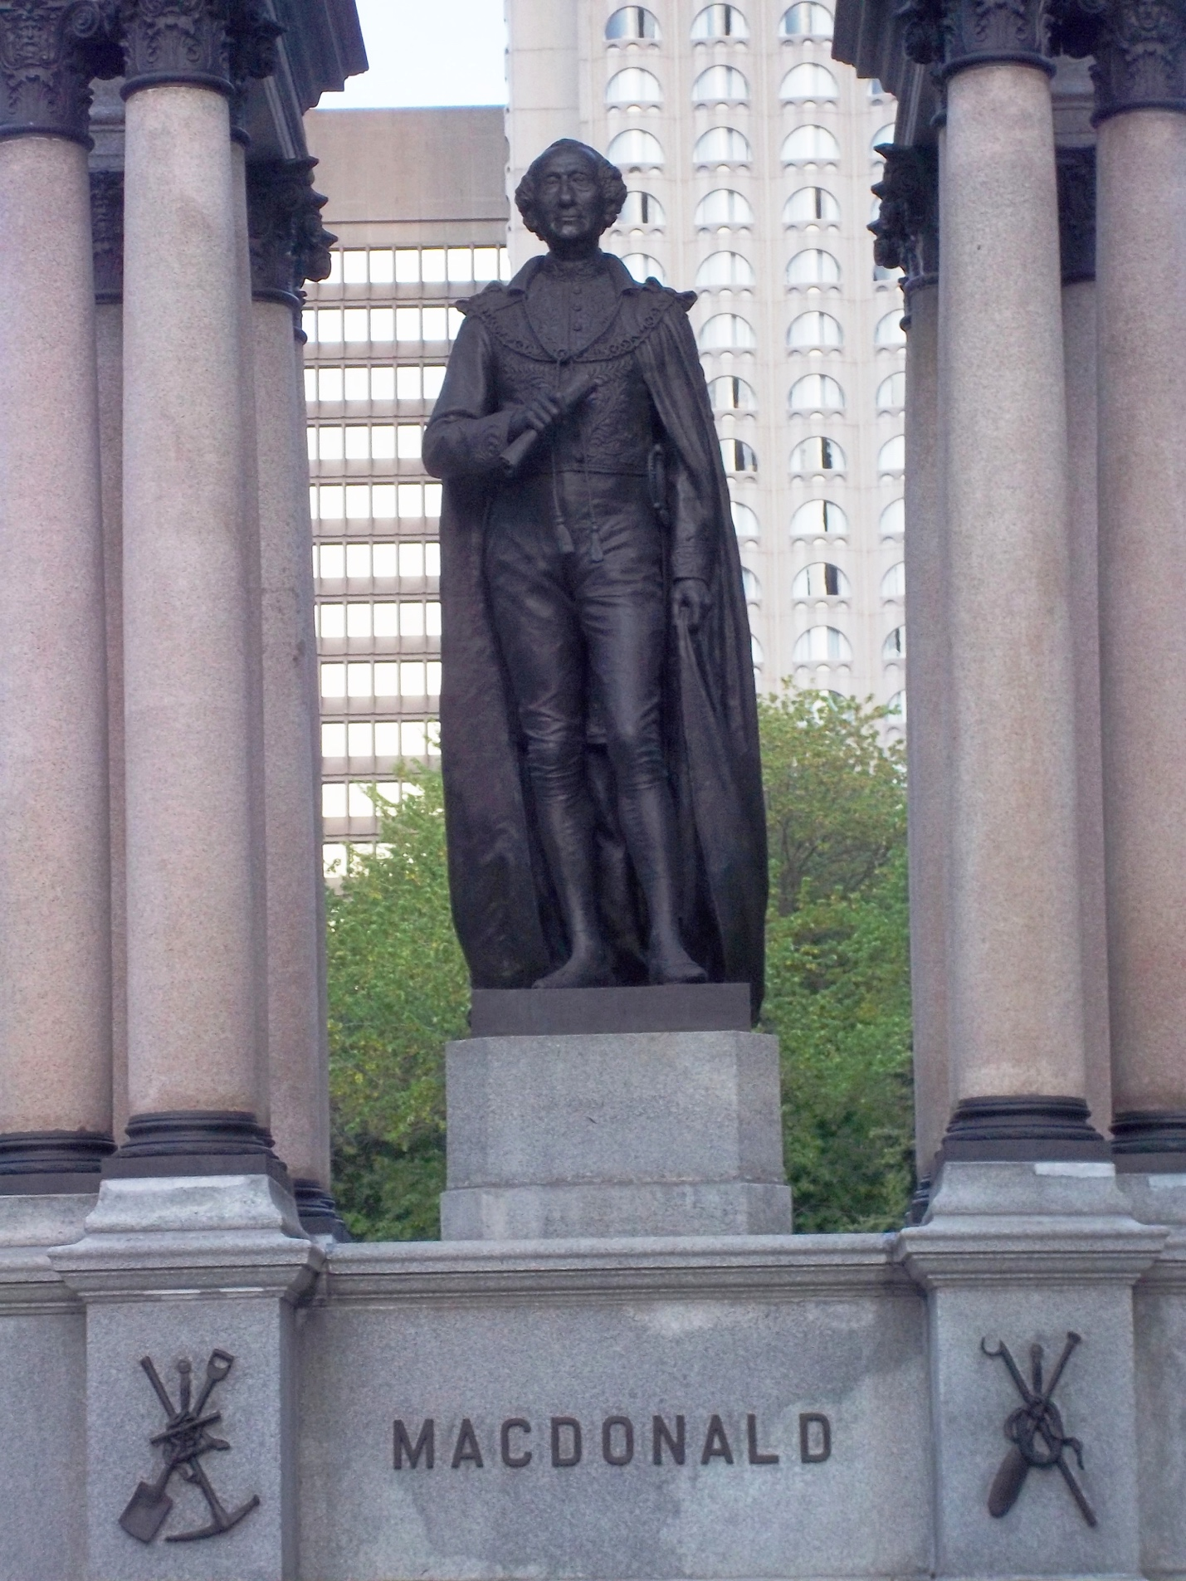

Edward Cornwallis statue in Halifax

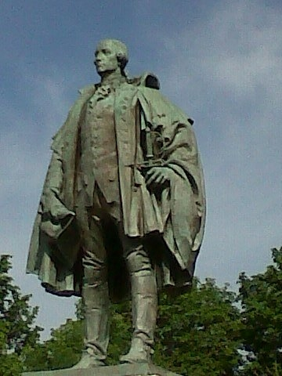

Samuel de Champlain statue in Orillia, Ontario

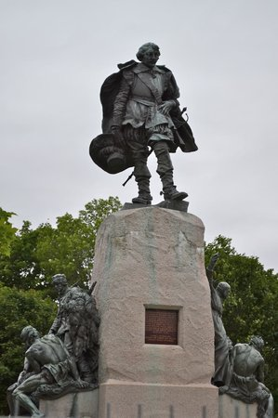

Wolseley Avenue and the Wolseley neighborhood, named after Sir Garnet Wolseley in Winnipeg, MB

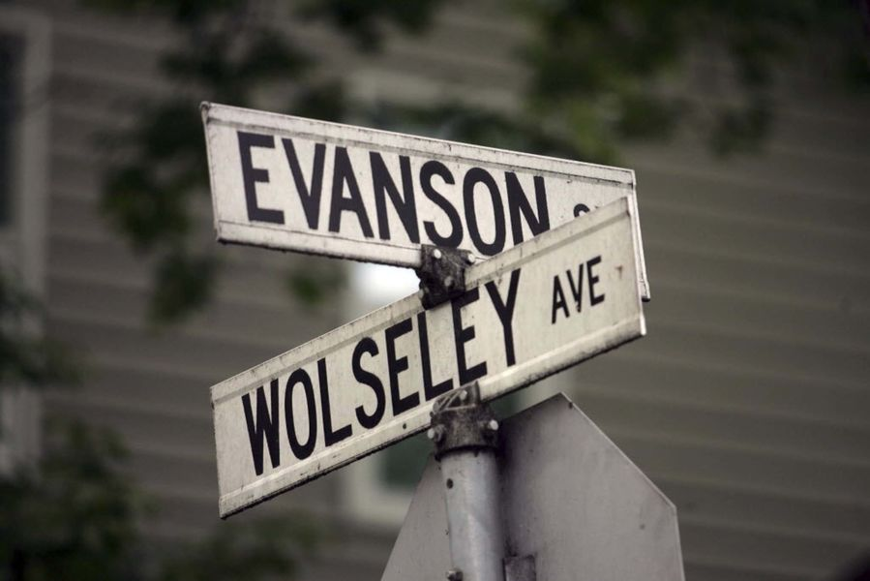

Hector-Louis Langevin; the Langevin Bridge in Calgary [though recently renamed the Reconciliation Bridge, signage still remains with the name Langevin Bridge]

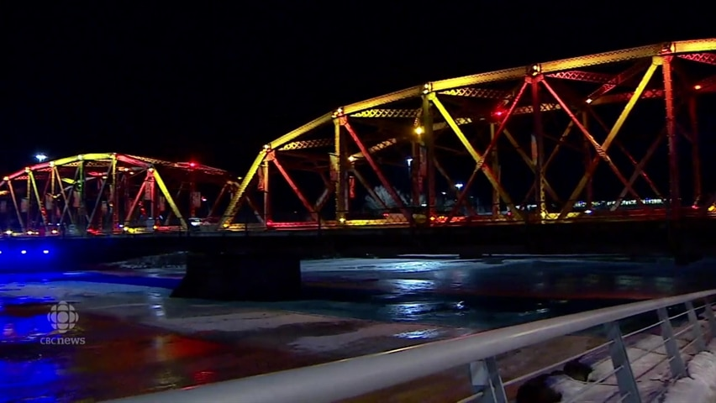

Joseph Trutch Residence at the University of Victoria; Trutch Street in Victoria

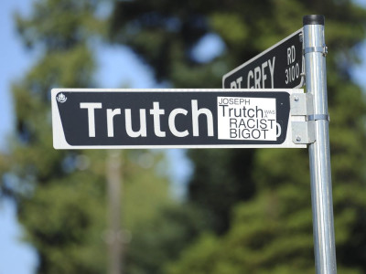

First Chief Justice Matthew Begbie statue at the Law Society of B.C.

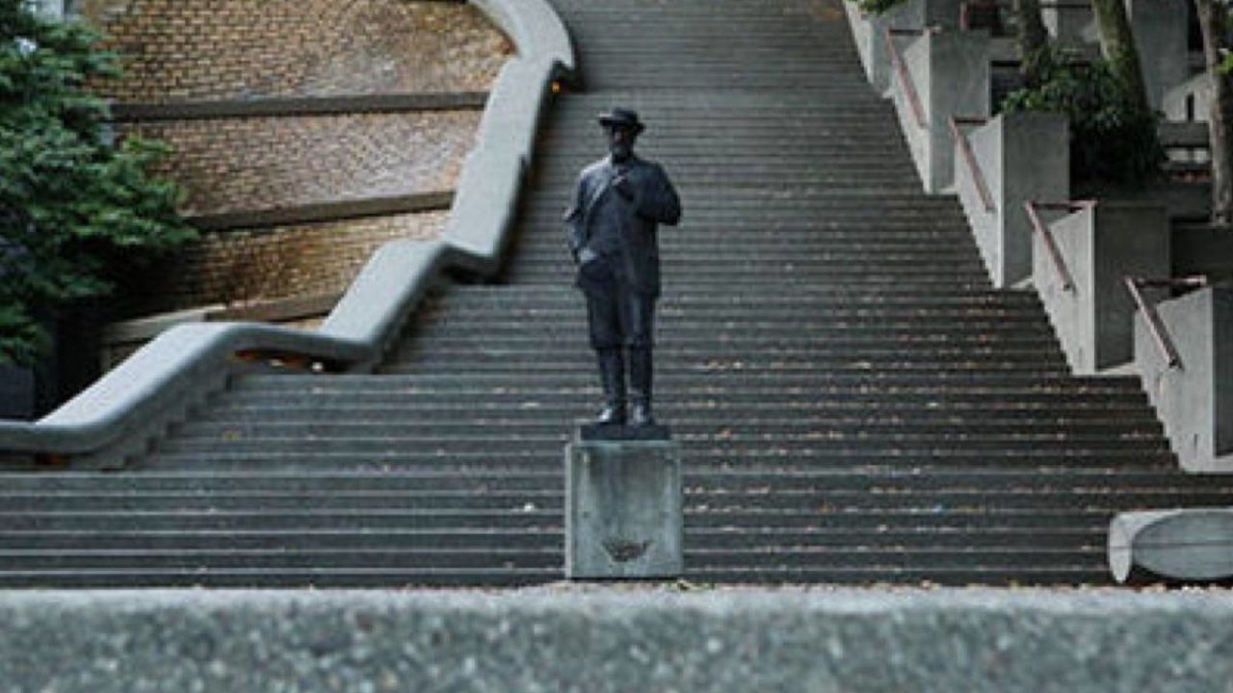

Egerton Ryerson – Ryerson University and statue in Ottawa

