The Artifact
Now that we have a little insight into the Renaissance, I want you to show me what you have learned. Think of this activity as our class making a museum of artifacts to be displayed in our classroom and then to have visitors looking at the displays and asking the curators questions about them.

PART 1:
The goal:
1. Make/ Create an artifact that shows something you are interested in about the Renaissance [See suggestions below for ideas].
2. Write three facts about this artifact [the original Renaissance piece] on a recipe card size piece of paper or typed on a Word document that you will email me.
3. Watch these videos to help with a display.
Visit: https://youtu.be/8Z2d8cidvqI
https://youtu.be/2YviD1Pcq9Y :to see how to make a museum display

4. Take a picture of your museum display.
5. Take a picture of your recipe card [Goal #2] or email me your Word document describing the three facts about this artifact.
6. Do a self-assessment using the chart below.

MYP Assessment:
 | 1-2 | 3-4 | 5-6 | 7-8
Criterion A: Knowing and understanding | - makes limited use of terminology  - demonstrates basic knowledge and understanding of content and concepts through limited descriptions and/or examples. | - uses some terminology accurately  - demonstrates satisfactory knowledge and understanding of content and concepts through simple descriptions, explanations and examples. | - uses considerable and relevant terminology accurately  - demonstrates substantial knowledge and understanding of content and concepts through descriptions, explanations and examples. | - consistently uses a range of terminology accurately  - demonstrates detailed knowledge and understanding of content and concepts through developed and accurate descriptions, explanations and examples.
Criterion C:  Communicating | - communicates information and ideas in a style that is not always clear  - organizes information and ideas in a limited way  - lists sources of information inconsistently. | - communicates information and ideas in a way that is somewhat clear  - somewhat organizes information and ideas  - creates an adequate reference list and sometimes cites sources. | - communicates information and ideas in a style that is mostly appropriate to the audience and purpose  - mostly structures information and ideas according to the task instructions  - creates an adequate reference list and usually cites sources. | - communicates information and ideas in a style that is completely appropriate to the audience and purpose  - structures information and ideas completely according to the task instructions  - creates a complete reference list and always cites sources.

There should be no financial expectation for this project. I have done several examples over the last few years and they have largely included objects/items I could find at home. Admittedly, I may have bought some glue or paint brushes or popsicle sticks, but those are easily found at the dollar store. The list below contains many examples that you can do without spending any money.
There is no expectation that you HAVE to do something off the list below. I just wanted to get you started on thinking about ideas.

Here are some suggestions to help you make the artifact:
1. Find a picture of something from the Renaissance, use a minimum of three things lying around the house, and recreate that image using those items. These examples show the original on the left and the recreation on the right. The first three are people recreating people and the last one uses food. Some awesome creativity.
https://www.classicfm.com/music-news/coronavirus/museum-challenges-people-recreate-famous-art/

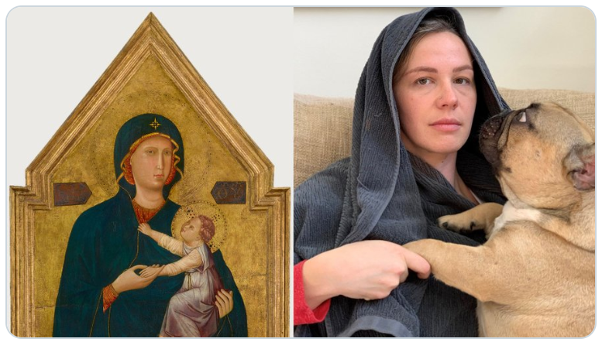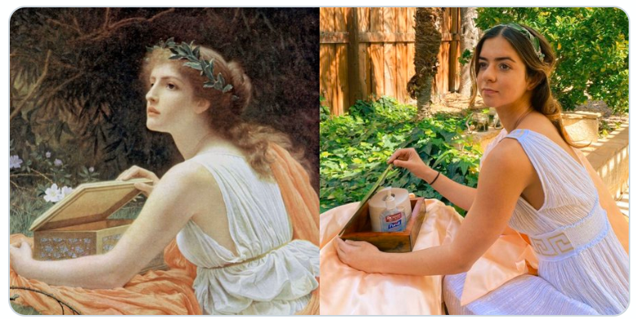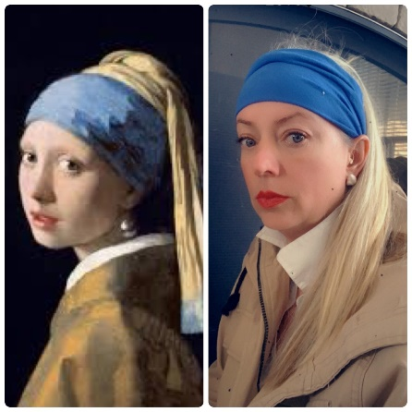

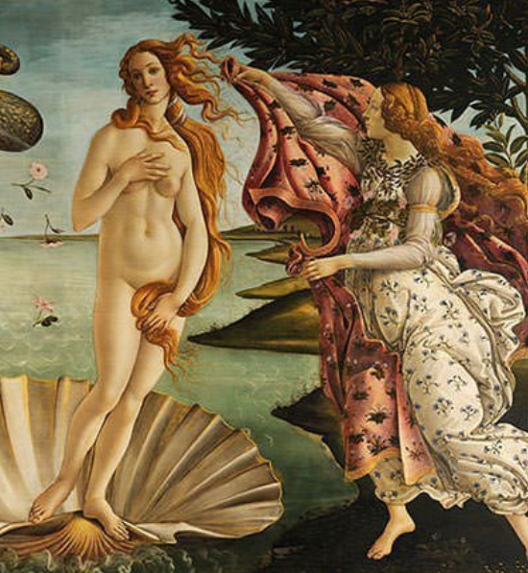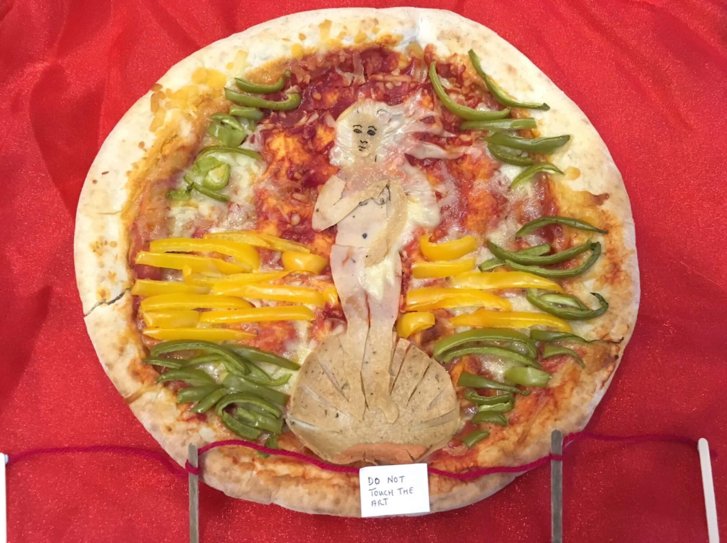

2. Tape a piece of paper under a short table or desk (a coffee table works great). Then collect some markers, pencil crayons, or a pencil and lie on your back under the table and draw a picture. Remember this is not about creating a super detailed or perfect work of art, rather this project allows you to experience what it must have been like to be Michelangelo and figure out how to create art on a canvas upside down. Here is a suggestion, a piece of the Sistine Chapel ceiling that I taped beside my blank page to try to recreate it.

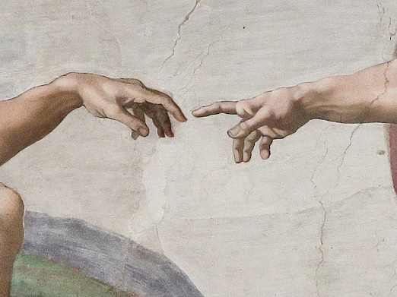

3. Leonardo da Vinci kept a notebook where he wrote down ideas throughout the day as he thought them up. It included sketches of everything you can imagine and little notes to himself including his shopping lists! He wrote the book in a form of coded mirror-writing so people couldn’t easily read his ideas. To make it even harder for them to steal his inventions da Vinci would often put a mistake in his diagrams on purpose. Create a page of da Vinci’s notebook for an invention.

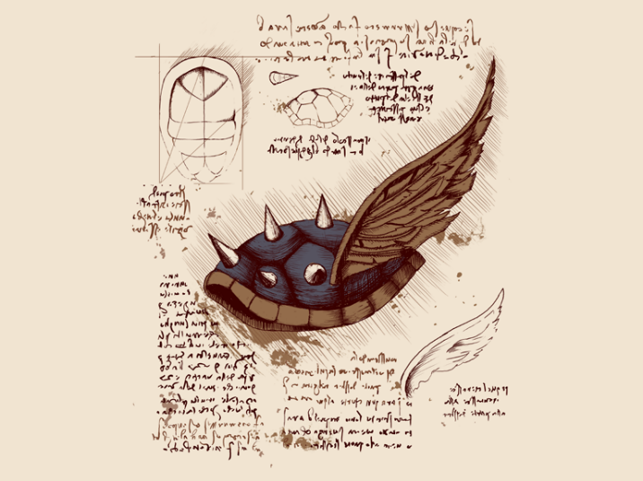

4. Draw an item showing Renaissance techniques. The video below shows an artist focusing on perspective and shadow as he draws.
https://youtu.be/cggZzePl1Z0

5. Those of you with musical talents, you could play a Renaissance piece. Think about the instrument used, the mood, the message and the audience…
https://youtu.be/FEBO1ibzSX4

6. Popsicle sticks and glue make great materials to re-create some Renaissance inventions. There are many YouTube videos to show you how to use this idea.

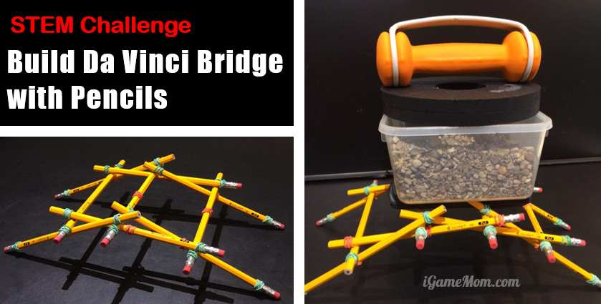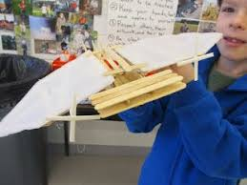

7. Recreate a Renaissance feast at home. Set the table, make the food and drink. Discuss who would eat this meal, what it is and when this would be served…

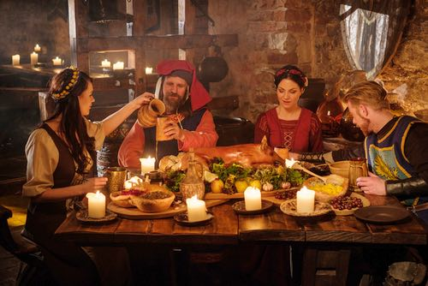

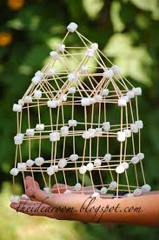
8. Use toothpicks and marshmallows to build some architecture during the Renaissance.

9. Follow other recipes online or on Youtube to make your own sculptures (ex. https://youtu.be/Pqcd29ZBVTg). There is always good ole paper machier.
https://youtu.be/TdPkoPwRkZ4

10. Make a renaissance article of clothing. There are many Youtube videos to help you with this, if you have some sewing skills and fabric.
https://youtu.be/ykhqMydeSdA

PART 2:
Presentation:
Using whatever platform works best for you, record yourself talking about your museum artifact. Explain what it is, how it represents what you learned and the process you took to make this artifact. Your “presentation” can be a video of you talking, a voiceover while we look at the screen with a picture of your artifact, you performing a voiceover in animation …I am completely open to ideas. Power Point and Google Slides work well too. I expect your presentation to be 30 secs to 1 minute long.

Assessment for presentation: (Criterion D)
 | 1-2 | 3-4 | 5-6 | 7-8
Criterion D:  Thinking critically | - begins to analyse concepts, issues, models, visual representation and/or theories in a limited way  - begins to identify connections between information to make simple arguments  - recognizes the origin and purpose of few sources/data as well as few values and limitations of sources/data  - identifies different perspectives. | - completes a simple analysis of concepts, issues, models, visual representation and/or theories  - summarizes information to make some adequate arguments  - analyses sources/data in terms of origin and purpose, recognizing some values and limitations  - recognizes different perspectives and suggests some of their implications. | - completes a substantial analysis of concepts, issues, models, visual representation and/or theories  - summarizes information in order to make usually valid arguments  - analyses sources/data in terms of origin and purpose, usually recognizing values and limitations  - clearly recognizes different perspectives and describes most of their implications. | - completes a detailed analysis of concepts, issues, models, visual representation and/or theories  - summarizes information to make consistent, well-supported arguments  - effectively analyses a range of sources/data in terms of origin and purpose, consistently recognizing values and limitations  - clearly recognizes different perspectives and consistently explains their implications.

